CTS WEEK 3:
Module 5 - Spring Core and Maven
Exercise 1: Configuring a Basic Spring Application
Scenario:
Your company is developing a web application for managing a library. You need to use the Spring Framework to handle the backend operations.
Steps:
- Set Up a Spring Project:
  - Create a Maven project named LibraryManagement.
  - Add Spring Core dependencies in the pom.xml file.
- Configure the Application Context:
  - Create an XML configuration file named applicationContext.xml in the src/main/resources directory.
  - Define beans for BookService and BookRepository in the XML file.
- Define Service and Repository Classes:
  - Create a package com.library.service and add a class BookService.
  - Create a package com.library.repository and add a class BookRepository.
- Run the Application:
  - Create a main class to load the Spring context and test the configuration.

SOLUTION:
Project Structure
LibraryManagement1
├── src
│ └── main
│ ├── java
│ │ └── com
│ │ └── library
│ │ ├── MainApp.java
│ │ ├── service
│ │ │ └── BookService.java
│ │ └── repository
│ │ └── BookRepository.java
│ └── resources
│ └── applicationContext.xml
└── pom.xml

Pom.xml:
<dependencies>
<dependency>
<groupId>org.springframework</groupId>
<artifactId>spring-context</artifactId>
<version>5.3.32</version>
</dependency>
</dependencies>

Right-click project → Maven → Update Project

applicationContext.xml
<?xml version="1.0" encoding="UTF-8"?>
<beans xmlns="http://www.springframework.org/schema/beans"
xmlns:xsi="http://www.w3.org/2001/XMLSchema-instance"
xsi:schemaLocation="
http://www.springframework.org/schema/beans
https://www.springframework.org/schema/beans/spring-beans.xsd">

<bean id="bookRepository" class="com.library.repository.BookRepository" />

<bean id="bookService" class="com.library.service.BookService">
<property name="bookRepository" ref="bookRepository"/>
</bean>

</beans>
- Package: com.library.repository and Add class BookRepository.java
package com.library.repository;

public class BookRepository {
public void saveBook(String bookName) {
System.out.println("Book \"" + bookName + "\" saved to the repository.");
}
}

- Package: com.library.service and Add class BookService.java
package com.library.service;

import com.library.repository.BookRepository;

public class BookService {
private BookRepository bookRepository;

public void setBookRepository(BookRepository bookRepository) {
this.bookRepository = bookRepository;
}

public void addBook(String bookName) {
System.out.println("BookService: Adding a book...");
bookRepository.saveBook(bookName);
}
}

- Package: com.library and Add class MainApp.java
package com.library;

import org.springframework.context.ApplicationContext;
import org.springframework.context.support.ClassPathXmlApplicationContext;
import com.library.service.BookService;

public class MainApp {
public static void main(String[] args) {
ApplicationContext context =
new ClassPathXmlApplicationContext("applicationContext.xml");

BookService bookService = context.getBean("bookService", BookService.class);
bookService.addBook("The Great Gatsby");
}
}

Right-click MainApp.java
Click Run As → Java Application

OUTPUT:
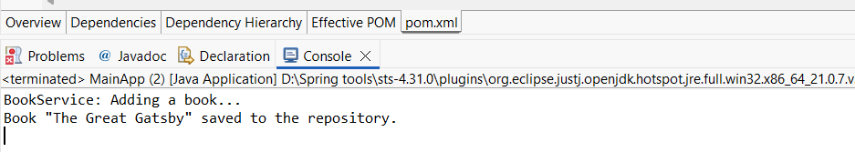

Exercise 2: Implementing Dependency Injection
Scenario:
In the library management application, you need to manage the dependencies between the BookService and BookRepository classes using Spring's IoC and DI.
Steps:
- Modify the XML Configuration:
  - Update applicationContext.xml to wire BookRepository into BookService.
- Update the BookService Class:
  - Ensure that BookService class has a setter method for BookRepository.
- Test the Configuration:
  - Run the LibraryManagementApplication main class to verify the dependency injection.

SOLUTION:

Modify applicationContext.xml
<?xml version="1.0" encoding="UTF-8"?>
<beans xmlns="http://www.springframework.org/schema/beans"
xmlns:xsi="http://www.w3.org/2001/XMLSchema-instance"
xsi:schemaLocation="http://www.springframework.org/schema/beans
https://www.springframework.org/schema/beans/spring-beans.xsd">
<bean id="bookRepository" class="com.library.repository.BookRepository" />

<!-- BookService Bean with Dependency Injection -->
<bean id="bookService" class="com.library.service.BookService">
<property name="bookRepository" ref="bookRepository" />
</bean>

</beans>

BookService.java

package com.library.service;

import com.library.repository.BookRepository;

public class BookService {
private BookRepository bookRepository;
public void setBookRepository(BookRepository bookRepository) {
this.bookRepository = bookRepository;
}

public void addBook(String bookName) {
System.out.println("BookService: Adding a book...");
bookRepository.saveBook(bookName);
}
}

MainApp.java:

package com.library;

import org.springframework.context.ApplicationContext;
import org.springframework.context.support.ClassPathXmlApplicationContext;
import com.library.service.BookService;

public class MainApp {
public static void main(String[] args) {

ApplicationContext context = new ClassPathXmlApplicationContext("applicationContext.xml");

BookService bookService = (BookService) context.getBean("bookService");
bookService.addBook("The Catcher in the Rye");
}
}

Run MainApp.java:

Right-click MainApp.java
Click Run As → Java Application

OUTPUT:

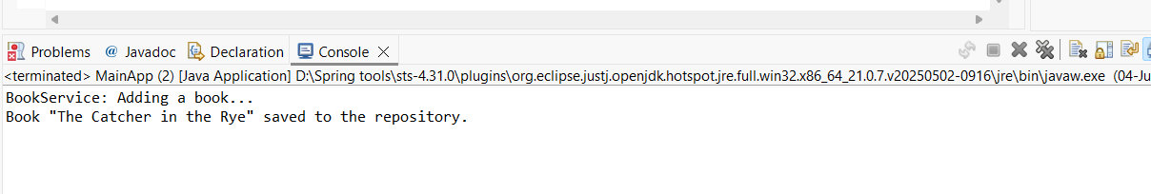

Exercise 4: Creating and Configuring a Maven Project
Scenario:
You need to set up a new Maven project for the library management application and add Spring dependencies.
Steps:
- Create a New Maven Project:
  - Create a new Maven project named LibraryManagement.
- Add Spring Dependencies in pom.xml:
  - Include dependencies for Spring Context, Spring AOP, and Spring WebMVC.
- Configure Maven Plugins:
  - Configure the Maven Compiler Plugin for Java version 1.8 in the pom.xml file.

SOLUTION:
New Maven Project - LibraryManagement
Group Id: com.library
Artifact Id: LibraryManagement
Version: 0.0.1-SNAPSHOT (default)
Packaging: jar
Name: LibraryManagement

Spring Dependencies to pom.xml:
<?xml version="1.0" encoding="UTF-8"?>
<project xmlns="http://maven.apache.org/POM/4.0.0"
xmlns:xsi="http://www.w3.org/2001/XMLSchema-instance"
xsi:schemaLocation="http://maven.apache.org/POM/4.0.0
https://maven.apache.org/xsd/maven-4.0.0.xsd">

<modelVersion>4.0.0</modelVersion>

<groupId>com.library</groupId>
<artifactId>LibraryManagement</artifactId>
<version>0.0.1-SNAPSHOT</version>
<packaging>jar</packaging>

<name>LibraryManagement</name>
<url>http://www.example.com</url>

<properties>
<project.build.sourceEncoding>UTF-8</project.build.sourceEncoding>
<maven.compiler.source>1.8</maven.compiler.source>
<maven.compiler.target>1.8</maven.compiler.target>
</properties>

<dependencies>
<dependency>
<groupId>org.springframework</groupId>
<artifactId>spring-context</artifactId>
<version>5.3.32</version>
</dependency>
<dependency>
<groupId>org.springframework</groupId>
<artifactId>spring-aop</artifactId>
<version>5.3.32</version>
</dependency>
<dependency>
<groupId>org.springframework</groupId>
<artifactId>spring-webmvc</artifactId>
<version>5.3.32</version>
</dependency>
</dependencies>

<build>
<plugins>
<plugin>
<groupId>org.apache.maven.plugins</groupId>
<artifactId>maven-compiler-plugin</artifactId>
<version>3.8.1</version>
<configuration>
<source>1.8</source>
<target>1.8</target>
</configuration>
</plugin>
</plugins>
</build>
</project>
Compile with Java 1.8:
- Package: com.library and Add class MainApp.java
MainApp.java
package com.library;

import java.util.Arrays;
import java.util.List;

public class MainApp {
public static void main(String[] args) {
List<String> books = Arrays.asList("A", "B", "C");
books.forEach(System.out::println); // Java 8 lambda expression
}
}

Run MainApp.java

Right-click MainApp.java
Click Run As → Java Application

OUTPUT:
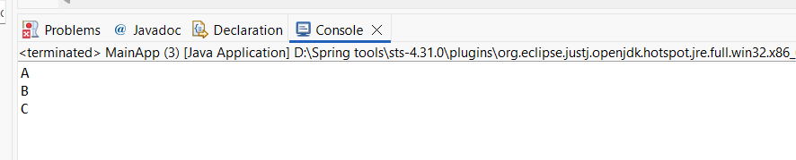

Module 6 - Spring Data JPA with Spring Boot, Hibernate
Spring Data JPA - Quick Example
Software Pre-requisites
- MySQL Server 8.0
- MySQL Workbench 8
- Eclipse IDE for Enterprise Java Developers 2019-03 R
- Maven 3.6.2
Create a Eclipse Project using Spring Initializr
- Go to https://start.spring.io/
- Change Group as “com.cognizant”
- Change Artifact Id as “orm-learn”
- In Options > Description enter "Demo project for Spring Data JPA and Hibernate"
- Click on menu and select "Spring Boot DevTools", "Spring Data JPA" and "MySQL Driver"
- Click Generate and download the project as zip
- Extract the zip in root folder to Eclipse Workspace
- Import the project in Eclipse "File > Import > Maven > Existing Maven Projects > Click Browse and select extracted folder > Finish"
- Create a new schema "ormlearn" in MySQL database. Execute the following commands to open MySQL client and create schema.
> mysql -u root -p

mysql> create schema ormlearn;
- In orm-learn Eclipse project, open src/main/resources/application.properties and include the below database and log configuration.
# Spring Framework and application log
logging.level.org.springframework=info
logging.level.com.cognizant=debug

# Hibernate logs for displaying executed SQL, input and output
logging.level.org.hibernate.SQL=trace
logging.level.org.hibernate.type.descriptor.sql=trace

# Log pattern
logging.pattern.console=%d{dd-MM-yy} %d{HH:mm:ss.SSS} %-20.20thread %5p %-25.25logger{25} %25M %4L %m%n

# Database configuration
spring.datasource.driver-class-name=com.mysql.cj.jdbc.Driver
spring.datasource.url=jdbc:mysql://localhost:3306/ormlearn
spring.datasource.username=root
spring.datasource.password=root

# Hibernate configuration
spring.jpa.hibernate.ddl-auto=validate
spring.jpa.properties.hibernate.dialect=org.hibernate.dialect.MySQL5Dialect
- Build the project using ‘mvn clean package -Dhttp.proxyHost=proxy.cognizant.com -Dhttp.proxyPort=6050 -Dhttps.proxyHost=proxy.cognizant.com -Dhttps.proxyPort=6050 -Dhttp.proxyUser=123456’ command in command line
- Include logs for verifying if main() method is called.
import org.slf4j.Logger;
import org.slf4j.LoggerFactory;

private static final Logger LOGGER = LoggerFactory.getLogger(OrmLearnApplication.class);

public static void main(String[] args) {
SpringApplication.run(OrmLearnApplication.class, args);
LOGGER.info("Inside main");
}
- Execute the OrmLearnApplication and check in log if main method is called.
SME to walk through the following aspects related to the project created:
- src/main/java - Folder with application code
- src/main/resources - Folder for application configuration
- src/test/java - Folder with code for testing the application
- OrmLearnApplication.java - Walkthrough the main() method.
- Purpose of @SpringBootApplication annotation
- pom.xml
  - Walkthrough all the configuration defined in XML file
  - Open 'Dependency Hierarchy' and show the dependency tree.
Country table creation
- Create a new table country with columns for code and name. For sample, let us insert one country with values 'IN' and 'India' in this table.
create table country(co_code varchar(2) primary key, co_name varchar(50));
- Insert couple of records into the table
insert into country values ('IN', 'India');
insert into country values ('US', 'United States of America');
Persistence Class - com.cognizant.orm-learn.model.Country
- Open Eclipse with orm-learn project
- Create new package com.cognizant.orm-learn.model
- Create Country.java, then generate getters, setters and toString() methods.
- Include @Entity and @Table at class level
- Include @Column annotations in each getter method specifying the column name.
import javax.persistence.Column;
import javax.persistence.Entity;
import javax.persistence.Id;
import javax.persistence.Table;

@Entity
@Table(name="country")
public class Country {

@Id
@Column(name="code")
private String code;

@Column(name="name")
private String name;

// getters and setters

// toString()

}
Notes:
- @Entity is an indicator to Spring Data JPA that it is an entity class for the application
- @Table helps in defining the mapping database table
- @Id helps is defining the primary key
- @Column helps in defining the mapping table column
Repository Class - com.cognizant.orm-learn.CountryRepository
- Create new package com.cognizant.orm-learn.repository
- Create new interface named CountryRepository that extends JpaRepository<Country, String>
- Define @Repository annotation at class level
import org.springframework.data.jpa.repository.JpaRepository;
import org.springframework.stereotype.Repository;

import com.cognizant.ormlearn.model.Country;

@Repository
public interface CountryRepository extends JpaRepository<Country, String> {

}
Service Class - com.cognizant.orm-learn.service.CountryService
- Create new package com.cognizant.orm-learn.service
- Create new class CountryService
- Include @Service annotation at class level
- Autowire CountryRepository in CountryService
- Include new method getAllCountries() method that returns a list of countries.
- Include @Transactional annotation for this method
- In getAllCountries() method invoke countryRepository.findAll() method and return the result
Testing in OrmLearnApplication.java
- Include a static reference to CountryService in OrmLearnApplication class
private static CountryService countryService;
- Define a test method to get all countries from service.
private static void testGetAllCountries() {
LOGGER.info("Start");
List<Country> countries = countryService.getAllCountries();
LOGGER.debug("countries={}", countries);
LOGGER.info("End");
}
- Modify SpringApplication.run() invocation to set the application context and the CountryService reference from the application context.
ApplicationContext context = SpringApplication.run(OrmLearnApplication.class, args);
countryService = context.getBean(CountryService.class);

testGetAllCountries();
- Execute main method to check if data from ormlearn database is retrieved.

SOLUTION:
MY SQL SETUP:
Create Schema:
CREATE DATABASE ormlearn;
Create Table:
USE ormlearn;

CREATE TABLE country (
code VARCHAR(2) PRIMARY KEY,
name VARCHAR(100)
);
INSERT INTO country (code, name) VALUES
('IN', 'India'),
('US', 'United States of America');
SELECT * FROM country;

TABLE OUTPUT:
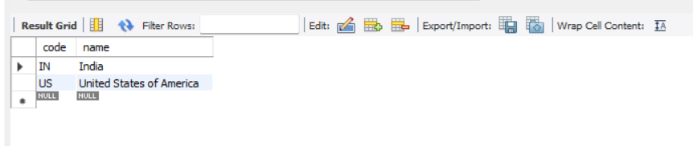File Structure:
orm-learn
│
├── src
│ ├── main
│ │ ├── java
│ │ │ └── com
│ │ │ └── cognizant
│ │ │ └── ormlearn
│ │ │ ├── OrmLearnApplication.java
│ │ │ ├── model
│ │ │ │ └── Country.java
│ │ │ ├── repository
│ │ │ │ └── CountryRepository.java
│ │ │ └── service
│ │ │ └── CountryService.java
│ │ └── resources
│ │ └── application.properties
└── pom.xml
Country.java
package com.cognizant.ormlearn.model;

import jakarta.persistence.Entity;
import jakarta.persistence.Id;
import jakarta.persistence.Table;

@Entity
@Table(name = "country")
public class Country {

@Id
private String code;

private String name;

public Country() {
}

public Country(String code, String name) {
this.code = code;
this.name = name;
}

public String getCode() {
return code;
}

public void setCode(String code) {
this.code = code;
}

public String getName() {
return name;
}

public void setName(String name) {
this.name = name;
}

@Override
public String toString() {
return "Country [code=" + code + ", name=" + name + "]";
}
}
CountryRepository.java
package com.cognizant.ormlearn.repository;

import org.springframework.data.jpa.repository.JpaRepository;
import com.cognizant.ormlearn.model.Country;

public interface CountryRepository extends JpaRepository<Country, String> {
}

CountryService.java
package com.cognizant.ormlearn.service;

import com.cognizant.ormlearn.model.Country;
import com.cognizant.ormlearn.repository.CountryRepository;
import org.springframework.beans.factory.annotation.Autowired;
import org.springframework.stereotype.Service;

import java.util.List;

@Service
public class CountryService {

@Autowired
private CountryRepository countryRepository;

public List<Country> getAllCountries() {
return countryRepository.findAll();
}
}

OrmLearnApplication.java
package com.cognizant.ormlearn;

import com.cognizant.ormlearn.model.Country;
import com.cognizant.ormlearn.service.CountryService;
import org.springframework.beans.factory.annotation.Autowired;
import org.springframework.boot.CommandLineRunner;
import org.springframework.boot.SpringApplication;
import org.springframework.boot.autoconfigure.SpringBootApplication;

import java.util.List;

@SpringBootApplication
public class OrmLearnApplication implements CommandLineRunner {

@Autowired
private CountryService countryService;

public static void main(String[] args) {
SpringApplication.run(OrmLearnApplication.class, args);
}

@Override
public void run(String... args) {
System.out.println("Start");
List<Country> countries = countryService.getAllCountries();
System.out.println("Countries: " + countries);
System.out.println("End");
}
}

Application.properties
spring.datasource.driver-class-name=com.mysql.cj.jdbc.Driver
spring.datasource.url=jdbc:mysql://localhost:3306/ormlearn
spring.datasource.username=root
spring.datasource.password=root123

spring.jpa.hibernate.ddl-auto=validate
spring.jpa.show-sql=true
spring.jpa.properties.hibernate.dialect=org.hibernate.dialect.MySQLDialect

Pom.xml
<dependencies>
<dependency>
<groupId>org.springframework.boot</groupId>
<artifactId>spring-boot-starter-data-jpa</artifactId>
</dependency>
<dependency>
<groupId>com.mysql</groupId>
<artifactId>mysql-connector-j</artifactId>
</dependency>
</dependencies>

Run the project:
cd /d "D:\Spring tools\orm-learn\orm-learn"
mvn spring-boot:run
OUTPUT:
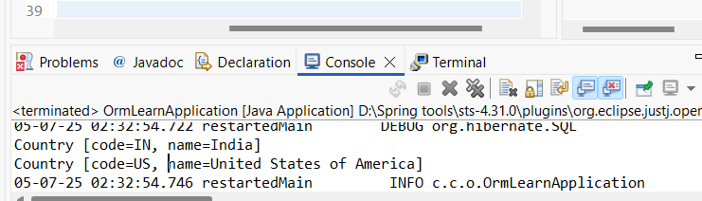

Difference between JPA, Hibernate and Spring Data JPA
Java Persistence API (JPA)
- JSR 338 Specification for persisting, reading and managing data from Java objects
- Does not contain concrete implementation of the specification
- Hibernate is one of the implementation of JPA
Hibernate
- ORM Tool that implements JPA
Spring Data JPA
- Does not have JPA implementation, but reduces boiler plate code
- This is another level of abstraction over JPA implementation provider like Hibernate
- Manages transactions
Refer code snippets below on how the code compares between Hibernate and Spring Data JPA
Hibernate
/* Method to CREATE an employee in the database */
public Integer addEmployee(Employee employee){
Session session = factory.openSession();
Transaction tx = null;
Integer employeeID = null;

try {
tx = session.beginTransaction();
employeeID = (Integer) session.save(employee);
tx.commit();
} catch (HibernateException e) {
if (tx != null) tx.rollback();
e.printStackTrace();
} finally {
session.close();
}
return employeeID;
}
Spring Data JPA
EmployeeRespository.java
public interface EmployeeRepository extends JpaRepository<Employee, Integer> {

}
EmployeeService.java
@Autowire
private EmployeeRepository employeeRepository;

@Transactional
public void addEmployee(Employee employee) {
employeeRepository.save(employee);
}
​​​​​​​
SOLUION:
MY SQL SETUP:
Create Schema:
CREATE DATABASE ormlearn;
Create Table:
USE ormlearn;
CREATE TABLE employee (
id INT AUTO_INCREMENT PRIMARY KEY,
name VARCHAR(100),
salary DOUBLE
);
Desc employee;
TABLE OUTPUT:
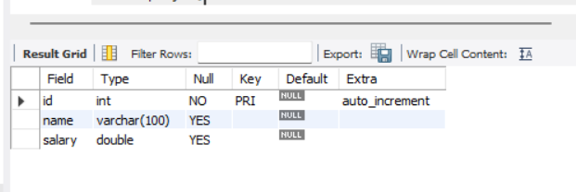
STRUCTURE:
orm-learn/
└── src/
└── main/
├── java/
│ └── com/cognizant/ormlearn/
│ ├── OrmLearnApplication.java
│ ├── model/Employee.java
│ ├── repository/EmployeeRepository.java
│ └── service/EmployeeService.java
└── resources/
└── application.properties

Application.properties
spring.application.name=orm-learn
logging.level.org.springframework=info
logging.level.com.cognizant=debug
logging.level.org.hibernate.SQL=trace
logging.level.org.hibernate.type.descriptor.sql=trace
logging.pattern.console=%d{dd-MM-yy} %d{HH:mm:ss.SSS} %-20.20thread %5p %-25.25logger{25} %25M %4L %m%n
spring.datasource.url=jdbc:mysql://localhost:3306/ormlearn
spring.datasource.username=root
spring.datasource.password=root123
spring.datasource.driver-class-name=com.mysql.cj.jdbc.Driver
spring.jpa.hibernate.ddl-auto=update
spring.jpa.show-sql=true
spring.jpa.properties.hibernate.dialect=org.hibernate.dialect.MySQLDialect

Employee.java
package com.cognizant.ormlearn.model;

import jakarta.persistence.*;

@Entity
@Table(name = "employee")
public class Employee {

@Id
@GeneratedValue(strategy = GenerationType.IDENTITY)
private int id;

private String name;

private double salary;

// Getters and Setters
public int getId() { return id; }

public void setId(int id) { this.id = id; }

public String getName() { return name; }

public void setName(String name) { this.name = name; }

public double getSalary() { return salary; }

public void setSalary(double salary) { this.salary = salary; }

@Override
public String toString() {
return "Employee [id=" + id + ", name=" + name + ", salary=" + salary + "]";
}
}

EmployeeRepository.java
package com.cognizant.ormlearn.repository;

import org.springframework.data.jpa.repository.JpaRepository;
import com.cognizant.ormlearn.model.Employee;

public interface EmployeeRepository extends JpaRepository<Employee, Integer> {

}

EmployeeService.java
package com.cognizant.ormlearn.service;

import com.cognizant.ormlearn.model.Employee;
import com.cognizant.ormlearn.repository.EmployeeRepository;
import org.springframework.beans.factory.annotation.Autowired;
import org.springframework.stereotype.Service;
import jakarta.transaction.Transactional;

@Service
public class EmployeeService {

@Autowired
private EmployeeRepository employeeRepository;

@Transactional
public void addEmployee(Employee employee) {
employeeRepository.save(employee);
}

public void printAllEmployees() {
employeeRepository.findAll().forEach(System.out::println);
}
}

OrmLearnApplication.java
package com.cognizant.ormlearn;

import com.cognizant.ormlearn.model.Employee;
import com.cognizant.ormlearn.service.EmployeeService;
import org.springframework.beans.factory.annotation.Autowired;
import org.springframework.boot.CommandLineRunner;
import org.springframework.boot.SpringApplication;
import org.springframework.boot.autoconfigure.SpringBootApplication;

@SpringBootApplication
public class OrmLearnApplication implements CommandLineRunner {

@Autowired
private EmployeeService employeeService;

public static void main(String[] args) {
SpringApplication.run(OrmLearnApplication.class, args);
}

@Override
public void run(String... args) throws Exception {
Employee emp1 = new Employee();
emp1.setName("John Doe");
emp1.setSalary(60000.0);
employeeService.addEmployee(emp1);

Employee emp2 = new Employee();
emp2.setName("Jane Smith");
emp2.setSalary(75000.0);
employeeService.addEmployee(emp2);

System.out.println("All Employees:");
employeeService.printAllEmployees();
}
}
Run the Project:

cd /d "D:\Spring tools\orm-learn\orm-learn"
mvn spring-boot:run

OUTPUT:

